**LAB ASSIGNMENT-5**

1. **Student Login Process**

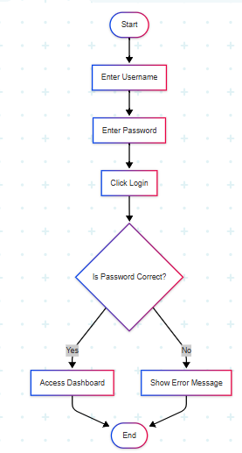

1. **ATM Cash Withdrawal Process**

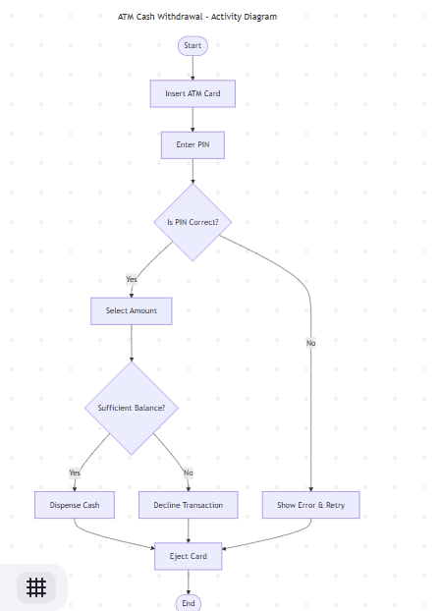

1. **Online Shopping Checkout (Parallel Execution)**

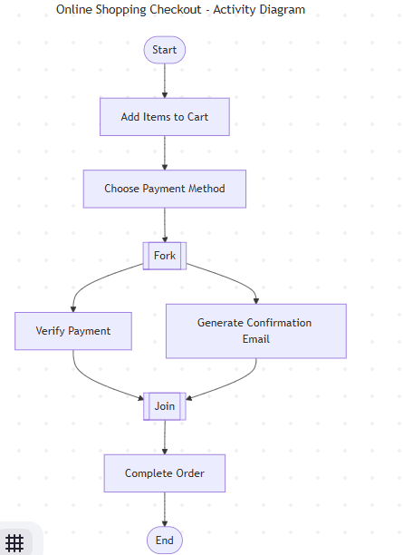

**✅ Lab Assignment 4: Hospital Appointment Booking**

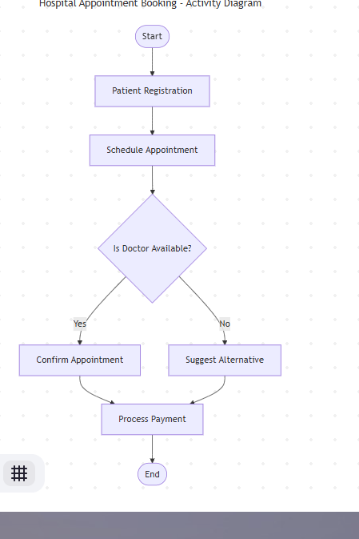

1. **: Movie Ticket Booking with Exception Handling**

